1. **Juicy Land**

**关于 JUICY LAND**

Play Juicy Land: The brand new match-3 game! Make your journey through the Juicy Land and complete challenging puzzles.

玩多汁的土地：全新的连线游戏！使您的旅程通过多汁的土地和完整的挑战性难题。

This game is a combination of what you love: challenge, fun, blasting, matching, solving puzzles and progressing in a unique adventure.  
这个游戏是一个你喜欢的组合：挑战，乐趣，爆破，匹配，解决难题和进展，在一个独特的冒险。

Match berries, fruits and many different Juicy Land elements to unleash great boosters and complete episodes of fun!

比赛的浆果、水果和许多不同的多汁的土地要素释放巨大的助推器和剧集的乐趣！

Start your journey with your animal friends and unlock challenging episodes by collecting sweet berries, passing different locations. Blast your enemies, collect the jam of the forest and continue your saga in this great adventure!

与你的动物朋友开始你的旅程，并通过收集甜蜜的浆果，通过不同的地点解锁挑战性的情节。吹你的敌人，收集森林的果酱，继续你的传奇在这个伟大的冒险！

Juicy Land Features:

- Great Story and fantastic world & Challenging levels with awesome animations

- More than 100 levels with different game modes and changing game play.

- Unique boosters & in-game items to help you in your journey.

多汁的土地特点：

•伟大的故事和神奇的世界和具有挑战性的水平与真棒动画

•100级以上不同的游戏模式和改变游戏玩法。

-独特的助推器与游戏中的物品来帮助你在你的旅程。

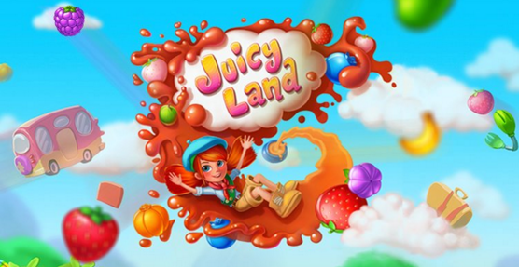

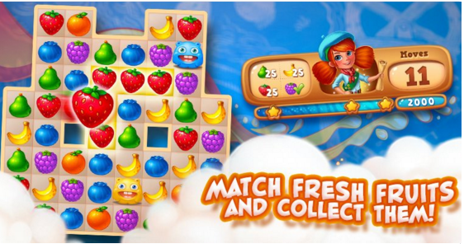



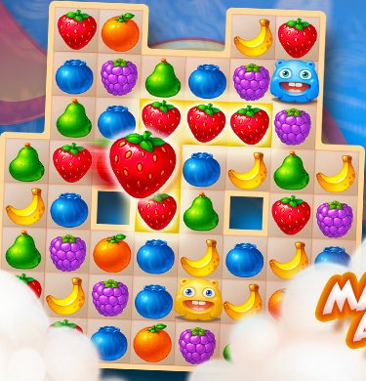

1. **Fruit Planet**

**关于 FRUIT PLANET**

Welcome to Fruit Planet!

Fruit Planet is an exciting match 3 game that anyone can enjoy. Collect 3 or more fruits to gain points and bonus points. Over 400 levels to play! Get ready for a tasty journey with your alien pal. Next stop, Fruit Planet!

水果星球是一个令人兴奋的比赛，任何人都可以享受3场比赛。收集3个或更多的水果，以获得积分和奖金点。超过400个级别的发挥！准备好你的外星朋友下一站美味水果星球的旅程！

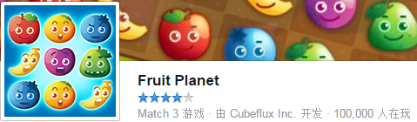

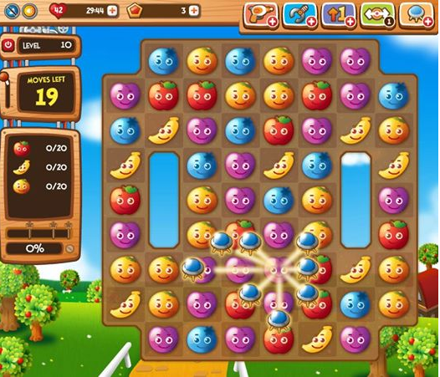

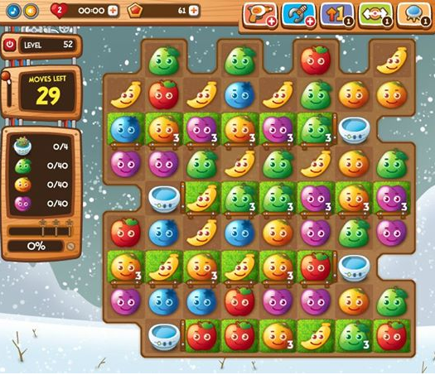

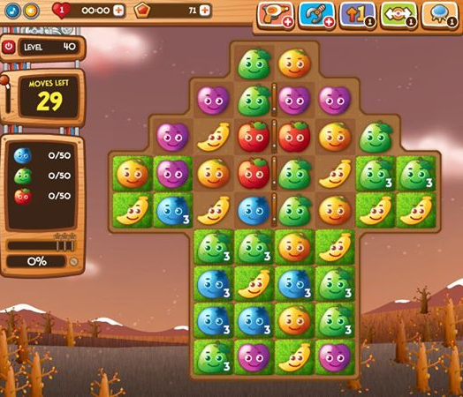

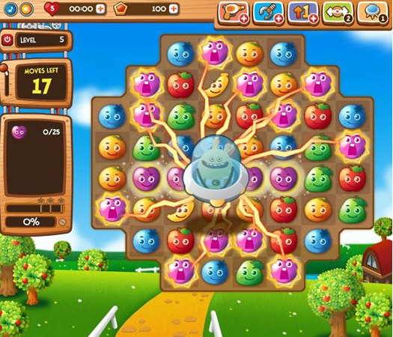

1. **Kingcraft - Puzzle Adventures**

**关于 KINGCRAFT - PUZZLE ADVENTURES**

Enter the world of Kingcraft and discover the countless kingdoms that are waiting to be conquered! Choose the prince or princess and, together with your faithful dragon, put your abilities to the test in this addictive puzzle match 3 game!

进入王道世界，发现等待征服了无数的王国！选择王子或公主，并与您的忠实的龙，把你的能力，在这个令人上瘾的益智游戏3游戏测试！

Fly with them through a magical world and choose which land you will conquer next. Raise your noble rank until becoming the king of the island! Many islands and thrones are waiting for you. Are you ready?

与他们一起穿越魔法世界，选择你将征服的土地。提高你的高贵地位，直到成为岛上的国王！许多岛屿和宝座等着你。你准备好了吗？

Every territory has its own challenges! You must match the vegetable patches in Farmland, the fruits in the forest and climb to the top of the mountains to collect the valuable gems and minerals.

每个领域都有它自己的挑战！你必须在农田里和蔬菜地上的补丁相匹配，在森林里的水果，爬到山顶去采集珍贵的宝石和矿物。

The richness of your lands will pave the way to new islands in which to expand your kingdom and great adventures. Play this challenging saga on your own or against your friends to see who can conquier the most kingdoms.

你的土地的丰富将铺平道路，以扩大你的王国和伟大的冒险的新岛屿。对自己或对你的朋友，看看谁能conquier最王国玩这个具有挑战性的传奇。

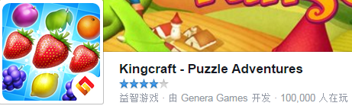

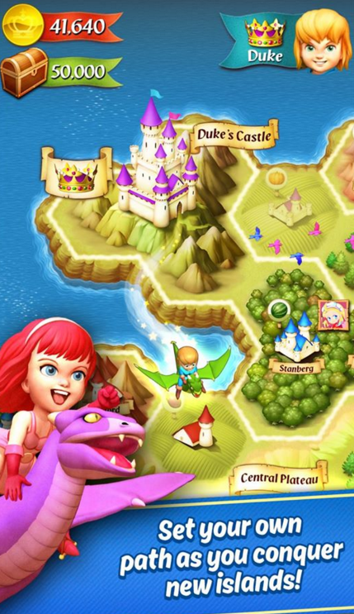

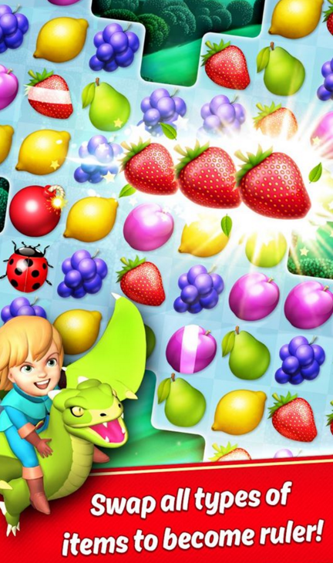

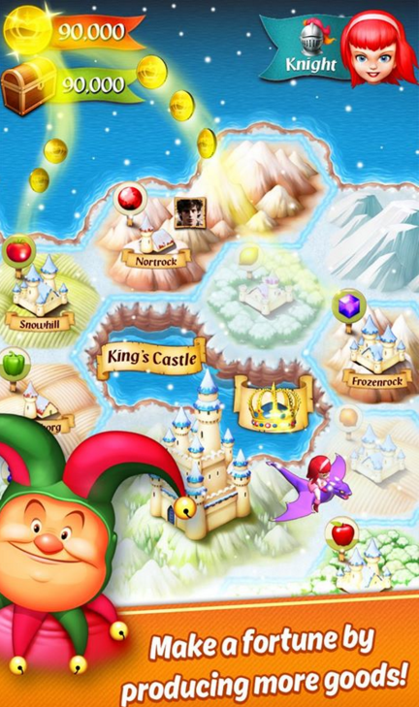

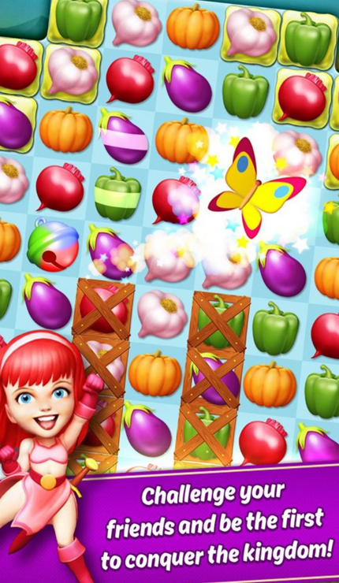

1. **Mo Candy**

**关于 MO CANDY**

YOUR TASTE BUDS are MELTING in your mouth and your SWEET TOOTH is rattling with the CRAVINGS of SOMETHING NEW, something sweeter than candy!

你的味蕾在嘴里融化，你的甜食是非常具有对新事物的渴望，比糖更甜的东西！

Quench your thirst for SOMETHING NEW with this beautiful DELICIOUSLY SWEET juicy candy, that only "MO CANDY" can deliver...

解渴的东西，新的与这个美丽的甘甜多汁的糖果，只有“莫糖果”可以提供…

For the sweet LOVE of CANDY…EvolutionRed presents Mo’ Candy, a CHARMING match three game for all you candy lovers in the world who CRAVE something NEW, something SWEETER than CANDY.

For 甜蜜 的 LOVE of CANDY … EvolutionRed 介绍 Mo ’ Candy ， 的 CHARMING 三 比赛 游戏 ， 所有 你 的 糖果 情人 在 世界 上 谁 是 CRAVE NEW ， 东西 SWEETER 比 CANDY.

An award winning, top seller and TOP RATED MATCH 3 app that's addictive like nothing else you HAVE ever TASTED or PLAYED.

一个屡获殊荣，畅销书和顶部额定匹配3个应用程序，这是你所喜欢的任何其他人一样，你从未尝过或玩。

Travel through an AMAZING WORLD of COLOR, MAGIC and FIREWORKS displays. Navigate through a variety of worlds to help "MO" collect the SWEET NECTAR of honey to make MAGICAL CANDIES.

通过一个令人惊奇的世界的颜色，魔术和烟花表演。导航通过各种世界，以帮助“莫”收集花蜜蜂蜜使神奇的糖果。

Every ten levels you will be DAZED with a NEW MAGICAL WORLD to EXPLORE.

MO CANDY is a Registered Trademark of EvolutionRed

All Rights Reserved 2015 EvolutionRed

每十级你会茫然的一个新的神奇世界的探索。

莫糖果是一个注册商标的evolutionred

版权所有2015 evolutionred

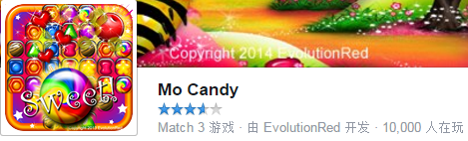



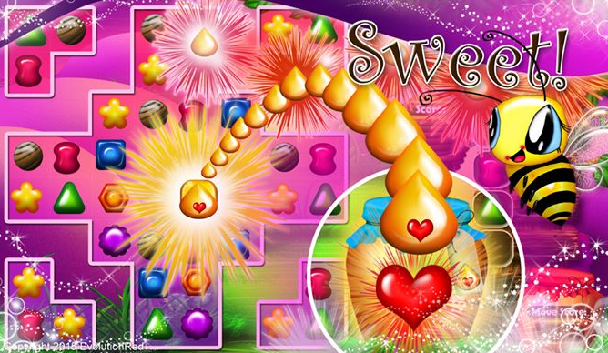

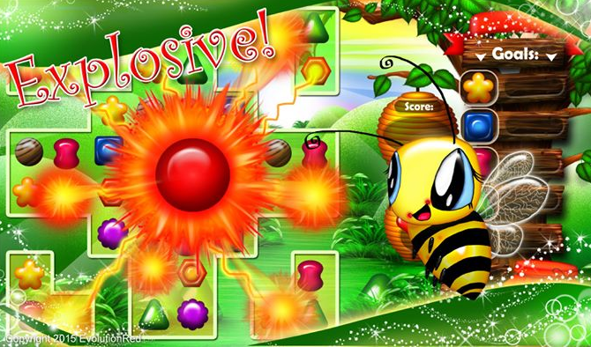

1. **Candy Valley**

**关于 CANDY VALLEY**

The sweetest game of the "3 in a row" genre.

A fascinating journey through the Candy Valley that will leave no one indifferent!

Unforgettable adventures, exciting logical levels and puzzling tasks.

一种“3排”游戏中最美妙的游戏。

一个迷人的旅程，通过糖果谷，将离开没有人无动于衷！

难忘的冒险，令人激动的逻辑水平和令人费解的任务。



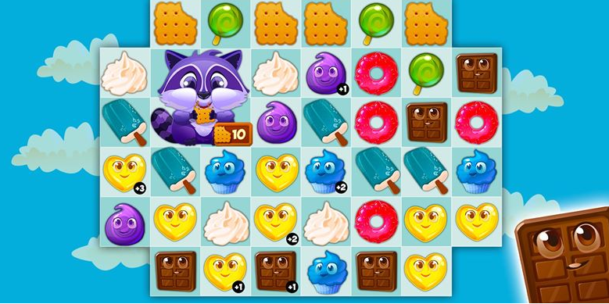

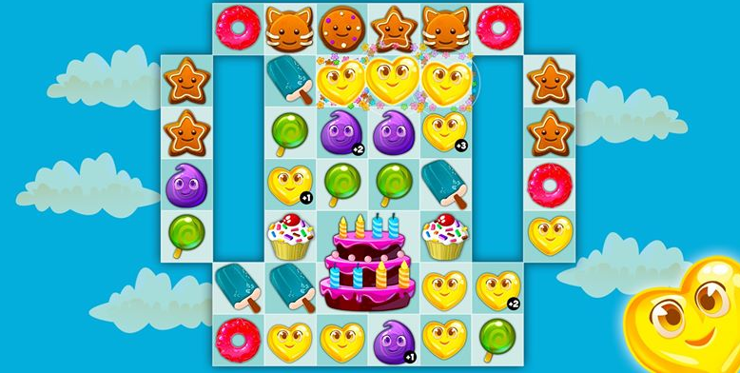

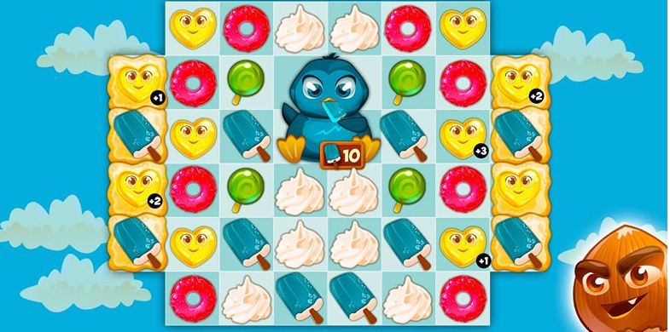

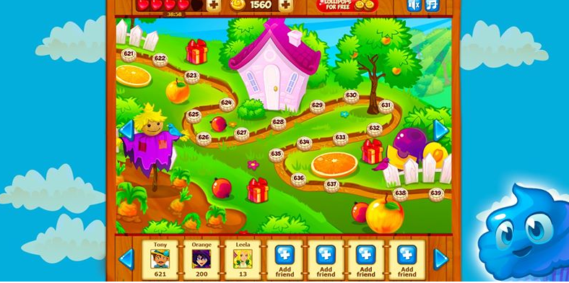

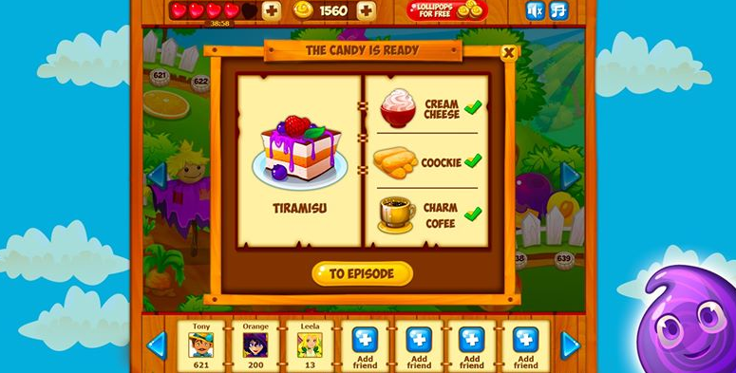

1. **Dr. Smile**

**关于 DR. SMILE**

Dr.Smile is a match-three puzzle game about human emotions. You are invited to help a well-known psychologist Dr. Gregory Smile and his equally notable sister Dr. Clarice Smile. They invented a new psychiatric treatment to cure the patients of their phobias and other mental problems. Your task is to apply this method practically and put human emotions in order! Your patients will be superstars and VIPs from the celebrity town Movieville. Let the treatment begin!

微笑是一个符合人类情感的三个谜题游戏。你被邀请去帮助一位著名的心理学家格雷戈瑞博士的微笑和他同样显著的妹妹博士克拉丽丝微笑。他们发明了一种新的精神病治疗的治愈他们的恐惧症和其他心理问题的病人。你的任务是把这个方法应用到实际中，把人类的情感放在秩序中！你的病人会从名人镇movieville巨星和贵宾。让治疗开始！

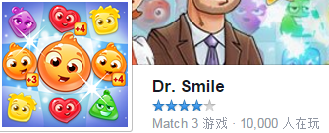

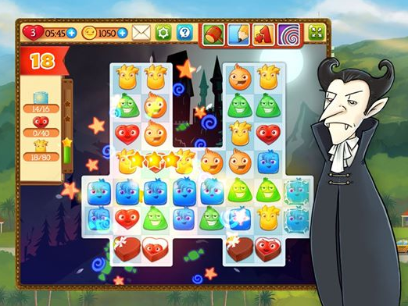

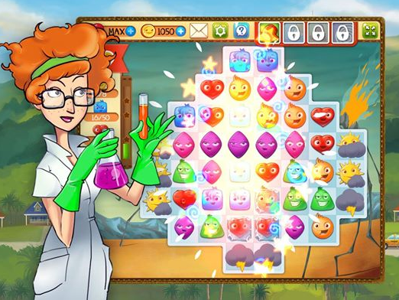

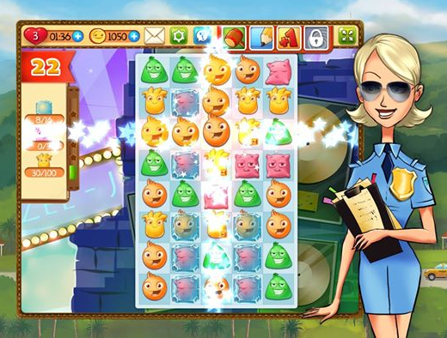

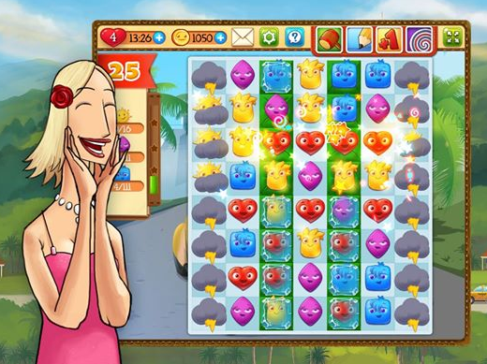

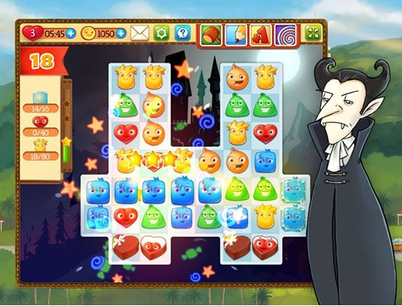

1. **Mables**

**关于 MABLES**

In far away Mableland kingdom are living lovely creation - Mables. And they had a great time before their king became evil and built walls between their meadows. Help the main heroes to make it all correct!

在遥远的mableland王国生活可爱的创作mables。他们在他们的国王面前有一个很好的时间，在他们的草地之间建造城墙。帮助主英雄，使之成为正确的！

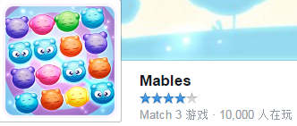

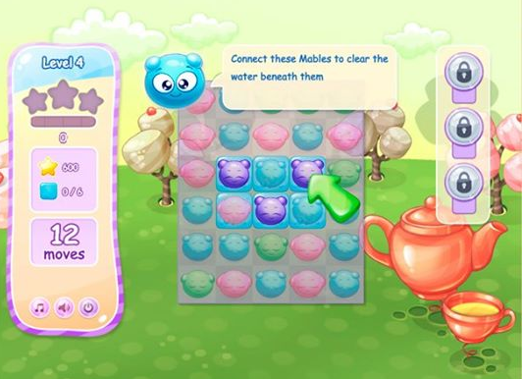

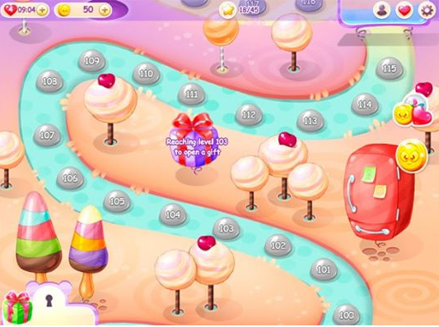

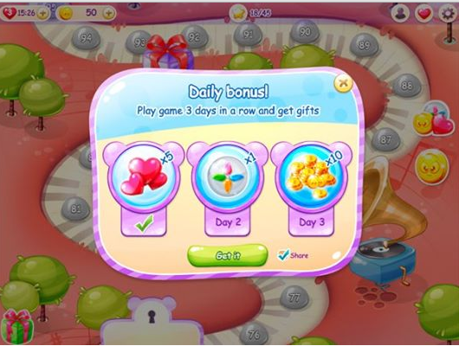

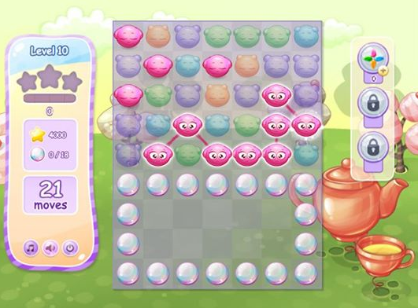

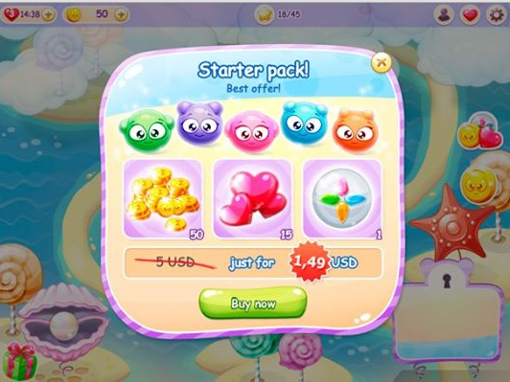

1. **Fresh Smash**

**关于 FRESH SMASH**

Tutti-frutti trip! Transform fruit into awesome gourmet desserts with jolly meerkats as you ride along the sunlit beaches of the match-3 world.

百果之旅！变换水果到可怕的美食甜点快乐蒙哥你骑在3世界阳光明媚的海滩。

In this exotic adventure you’ll cook oodles of divine desserts from a recipe book! Complete dozens of challenging fruit-packed levels by smashing pineapples, blending berries, jamming kiwis and mixing all sorts of fruit and fruit cakes in lines of 3.

在这奇异的冒险你会做甜点的食谱书很多神圣！完成几十个具有挑战性的水果包装水平由碎菠萝，混合浆果，干扰猕猴桃和混合各种线3水果和水果蛋糕。

What else? Fruit battles with coyote, quests with сoconut cocktail cup making and turtle waking, and a set of ultra-powerful boosters to help you!

还有什么？狼的水果的战斗，与сoconut鸡尾酒杯和龟醒来的任务，和一套超强力助推器来帮助你

Fresh Smash is a free-to-play game that contains optional in-app purchases which may improve your score.

新鲜粉碎是一个免费的游戏，其中包含可选的应用程序购买，这可能提高你的分数。



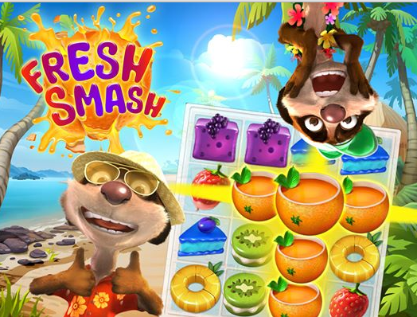

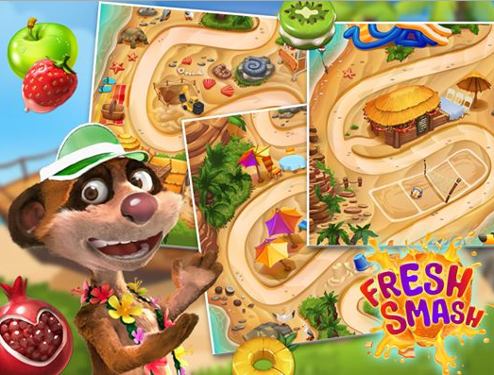

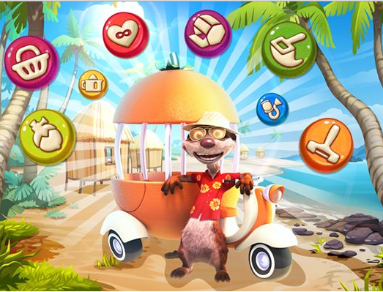

**九、Indy Cat**

**关于 INDY CAT**

The game has absorbed the best qualities of the genre, seasoned with its own unique features. From the very beginning of the game you are fully immersed in the gameplay, and scenic spots, colorful graphics, stunning effects and addictive game genre just does not let you put it down!

这场游戏吸收了这类游戏的最佳品质，以它自己独特的特点。从游戏开始，你完全沉浸在游戏中，风景区，丰富多彩的图形，迷人的效果和令人上瘾的游戏类型，只是不让你把它！

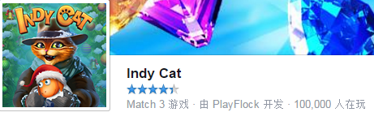

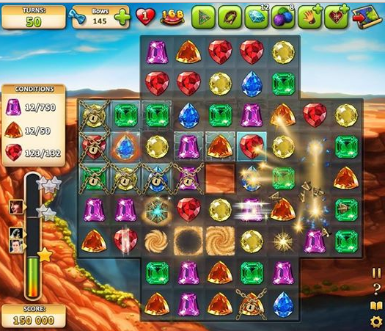

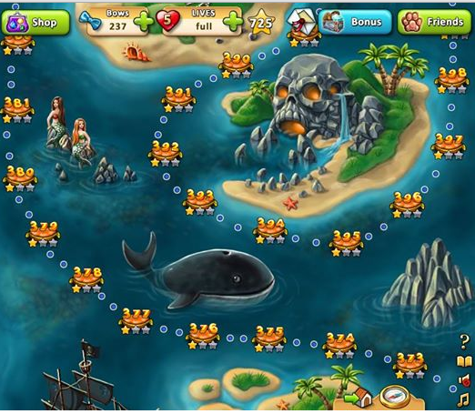

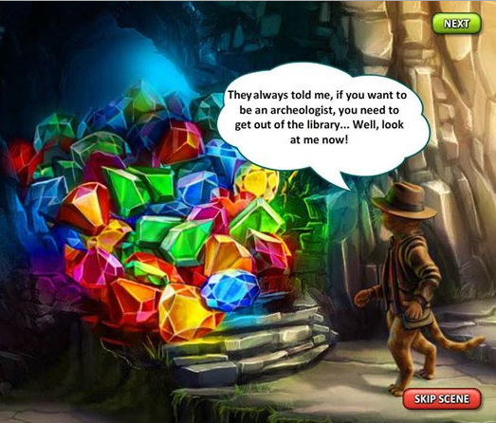

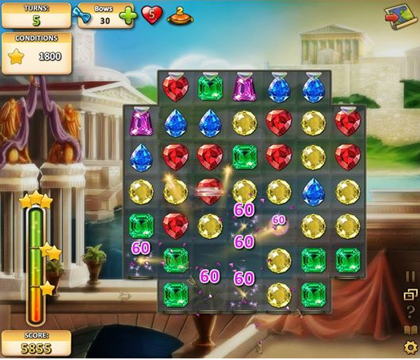

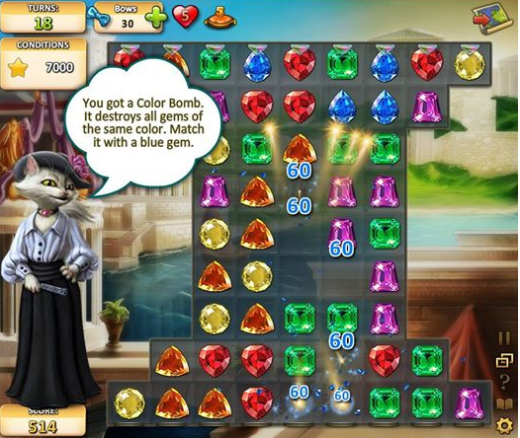

十、**Bejeweled Blitz**

**关于 BEJEWELED BLITZ**

Treat yourself to PopCap's exciting twist on its classic Bejeweled game, where you match and detonate as many gems as you can in 60 seconds! By matching 3 or more, you create cascades of fun with Flame gems, Star gems, and Hypercubes. Combine these with a selection of Boosts and powerful Rare Gems to achieve a high score and compete with friends to dominate the weekly leader boards!

对待自己的激动人心的扭曲对宝石的经典游戏，在那里你的比赛，引爆尽可能多的宝石，你可以在60秒！通过匹配3个或更多，你创建级联的乐趣与火焰宝石，星宝石和超立方体。结合这些与一个选择的提升和强大的稀有宝石，以实现高得分，并与朋友竞争，占据主导地位的周领导板！

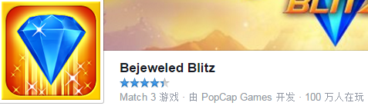

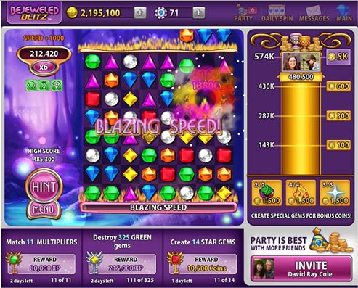

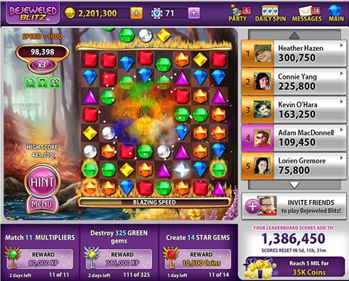

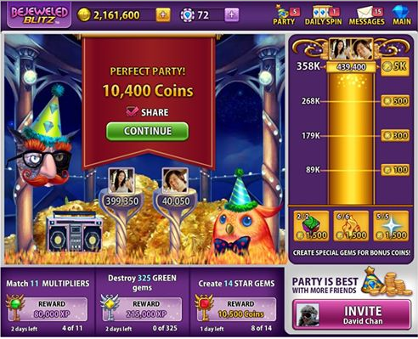

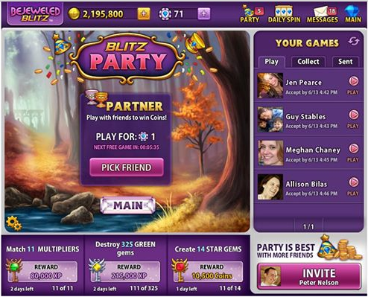

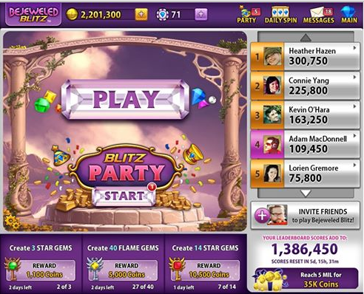

**十一、Christmas Puzzle Mix**

**关于 CHRISTMAS PUZZLE MIX**

► Christmas Puzzle Mix is a Match-3 super hit! You haven’t seen such a puzzle before: flying platforms, magical portals, destructive cannons, and enchanted bees.

圣诞拼图组合是一个3超级打！你还没有见过这样一个谜：飞行平台，神奇的门户网站，破坏性的大炮，和迷人的蜜蜂。

► The fascinating thriller where little sorceress Jeannie defends Fairy Land from the intrigues of the evil witch Vivienne de Legrand.

迷人的惊悚片在小女巫珍妮守仙境从邪恶的女巫Vivienne de罗格朗的阴谋。

► More than 30 abandoned mines and workshops as well as 15 ruined buildings on the estate. Banish the evil, collect the resources, restore the estate, and receive bonuses for the game.

超过30个废弃的矿山和厂房以及15个毁坏的建筑物。驱除邪恶，收集资源，恢复地产，和比赛的奖金。

► 15 locations, 300 levels, and even more await you beyond the portal of Fairy Land.

15个地点，300个层次，甚至更多的等待你超越了童话之门。

► Use a powerful booster, spin the Wheel of Fortune, and get valuable gifts from the daily bonus!

使用强大的助推器，旋转的财富，并从每日奖金获得宝贵的礼物！

► Invite your friends to the game, compete with them, help them to pass difficult levels, and receive lives from them!

邀请你的朋友们参加比赛，和他们比赛，帮助他们度过困难的水平，并且接受他们的生活！



